Ex.No:1: Simulation of FDMA in MATLAB Date
Aim: To simulate a Frequency Division Multiple Access (FDMA) system using MATLAB and analyze its communication performance in terms of channel bandwidth, data rate, and signal-to-noise ratio (SNR).
Objective 1:
To simulate an FDMA system by allocating individual frequency channels to multiple users and determine the channel bandwidth assigned to each user.
Output Parameter: Channel Bandwidth (kHz)
Objective 2:
To calculate the data rate achieved by each user in the FDMA system based on the allocated channel bandwidth.
Output Parameter: Data Rate (kbps)
Objective 3:
To evaluate the communication quality of the FDMA system by calculating the Signal-to Noise Ratio (SNR) for different users.
Output Parameter: Signal-to-Noise Ratio (SNR) (dB)
Procedure
1. Open MATLAB and create a new script file.
2. Define the total available bandwidth, number of FDMA users, carrier frequencies, signal power, and noise power.
3. Allocate a unique frequency channel to each user and calculate the channel bandwidth. 4. Compute the data rate for each user based on the allocated bandwidth and modulation scheme.
5. Calculate the Signal-to-Noise Ratio (SNR) using the signal and noise power values. 6. Plot the transmitted signals of all FDMA users using different carrier frequencies. 7. Display the calculated channel bandwidth, data rate, and SNR in the MATLAB Command Window.
8. Analyze the results to verify independent channel allocation and evaluate the overall performance of the FDMA system.
Program (Matlab Code)
clc; clear; close all;
fs=1000; t=0:1/fs:1;
TBW=600; Users=3;
CBW=TBW/Users;
fc=[100 300 500];
m=sin(2*pi*10*t);
s1=m.*cos(2*pi*fc(1)*t);
s2=m.*cos(2*pi*fc(2)*t);
s3=m.*cos(2*pi*fc(3)*t);
subplot(2,1,1)
plot(t,s1,'r',t,s2,'g',t,s3,'b'),grid on
title('FDMA Channel Allocation'),xlabel('Time (s)'),ylabel('Amplitude') subplot(2,1,2)
bar(1:Users,CBW*ones(1,Users)),grid on
xlabel('Users'),ylabel('Channel Bandwidth (kHz)'),title('Channel Bandwidth per User')
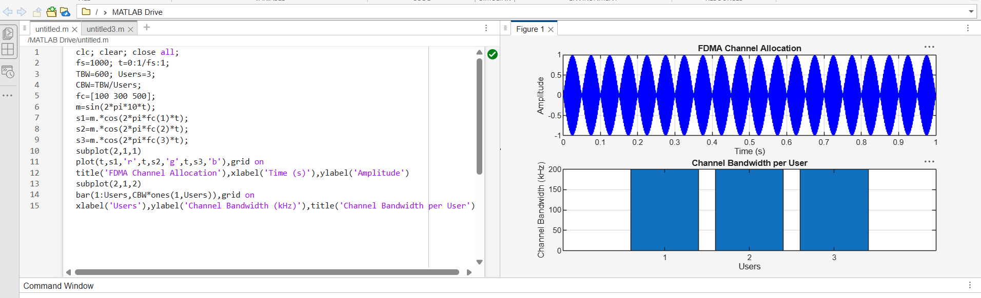
clc; clear; close all;
BW = 200; % Channel Bandwidth (kHz)
Users = 3;
M = 2; % BPSK Modulation
DataRate = BW*log2(M); % Data Rate (kbps)
Rate = DataRate*ones(1,Users);
disp(' User Data Rate (kbps)')
disp([(1:Users)' Rate'])
figure
bar(1:Users,Rate)
xlabel('Users')
ylabel('Data Rate (kbps)')
title('FDMA Data Rate for Each User')
grid on
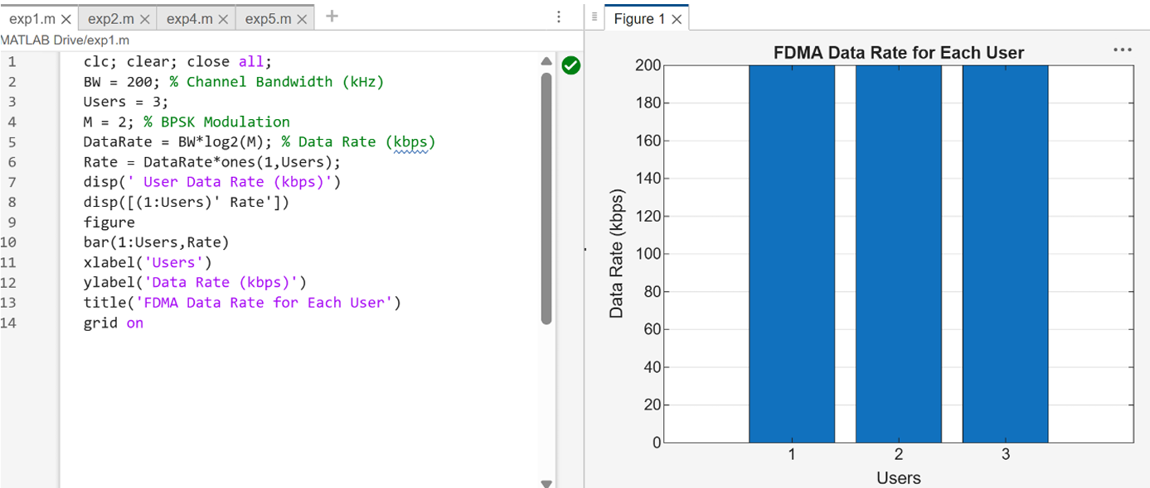

clc; clear; close all;
Ps = 1; % Signal Power (W)
Pn = [0.1 0.05 0.01]; % Noise Power (W)
Users = 1:3;
SNR = 10*log10(Ps./Pn); % SNR in dB
disp('User Noise Power(W) SNR(dB)')
disp([Users' Pn' SNR'])
figure
bar(Users,SNR)
xlabel('Users')
ylabel('SNR (dB)')
title('Signal-to-Noise Ratio of FDMA Users')
grid on
